*Florida International University*

*School of Computing and Information Sciences*

CIS 4911 - Senior Capstone Project

Software Engineering Focus

Feature Document

User Story #549

**Team Member:**

Andrew Mitchell

**Product Owner(s)**:

Francisco R. Ortega

**Mentor(s)**:

Francisco R. Ortega

...

**Instructor**: Masoud Sadjadi

# 

# **User Story - Change Background Color**

* As a User I would like to change the background color so I can work on different canvas colors.

## **Use Case – Change Background Color**

Use Case

Change Background color

Details:

Actor: User

Pre-conditions:

Program Running.

Description:

Use case begins when a user presses a key (b, Temporary until design philosophy is completed). This will alter the color of the background.

Post-conditions:

Background changes color.

The eraser changes colors.

Decision Support:

Frequency: Sometimes. Some users may prefer dark or light background.

Criticality: Slight. Enables more ways to paint on the canvas.

Risk: Low. Should be a simple implementation.

Constraints:

Usability:

Just need to learn the proper keybinding.

Reliability: Very Reliable.

Mean time to Failure – Should only fail in extreme conditions. (Keyboard input overloads etc).

Availability – Always available (may change at a future date).

Performance:

Color changes should be swift.

Supportability:

Modification History:

Owner: Andrew Mitchell

Initiation date: 02/2/2016

Date last modified: 02/14/2016

## 

## 

## **Use Case Diagram**

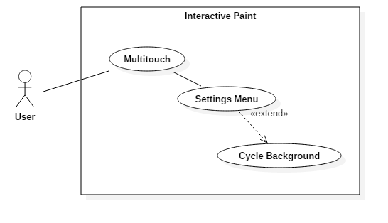

## **Sequence Diagram**

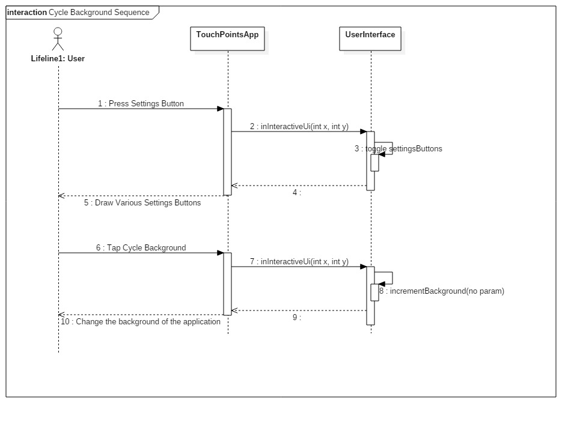

## 

## 

## 

## 

## 

## 

## 

## **Class Diagram**

## C:\Users\IEatR\Pictures\Cycle Background Class.png

## **Unit Test**

Sunny Day Tests

Test Case: Change Background Color

Test Purpose:

Ensure that we can change background color.

Test Setup:

1. Press the ‘cog’ in the mode box (bottom right).
2. Press the ‘Cycle Background button’
3. Continue pressing until background is white.

Test Output:

Every press of ‘Cycle Background’ changed the background color.

Expected Output:

The background should cycle through various colors, and eventually return to white.

Rainy Day Tests

Test Case: Save Images with background.

Test Purpose:

Make sure the background saves with the drawing.

Test Setup:

1. Draw a few lines
2. Change background
3. Press ‘n’ to save image.
4. Repeat step 2 – 3 until you return to the white background.

Test Output:

Each saved images had a different background (except transparent appeared white)

Expected Output:

Every background should have saved a different background color.

## **Integration Test**

Currently works with leap save and regular keyboard save function.

Currently works with layer implementations, as well as any shape implementation

Works with all the drawing methods.

## 

## 

## **User Guide**

Use the settings menu in the mode box to open the settings menu.

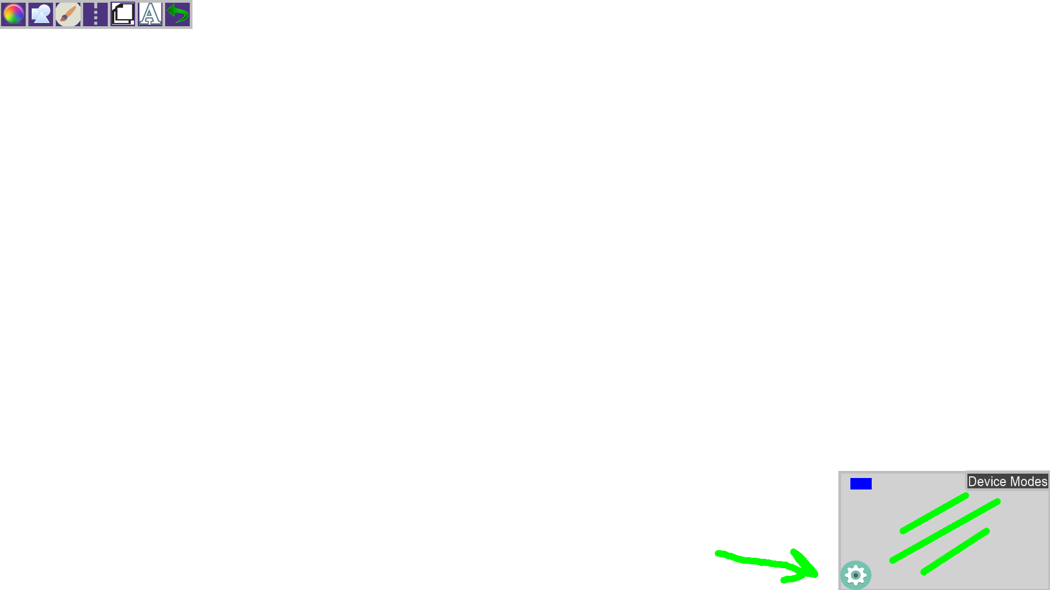

Then tap the ‘Cycle Background’ button to change backgrounds until you find the one you want!

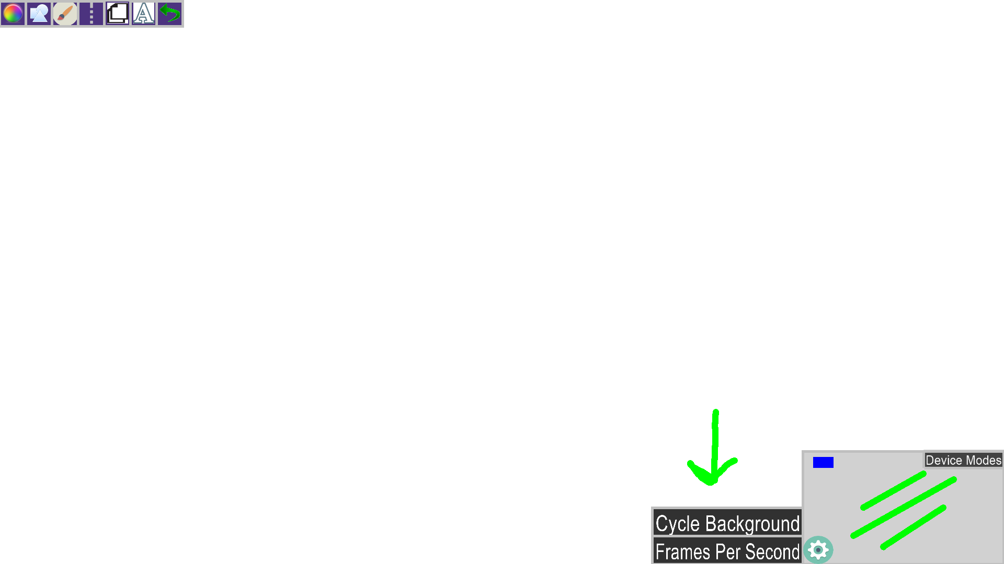

A checkerboard background indicates a ‘Transparent’ background, meaning the background will be empty pixels.

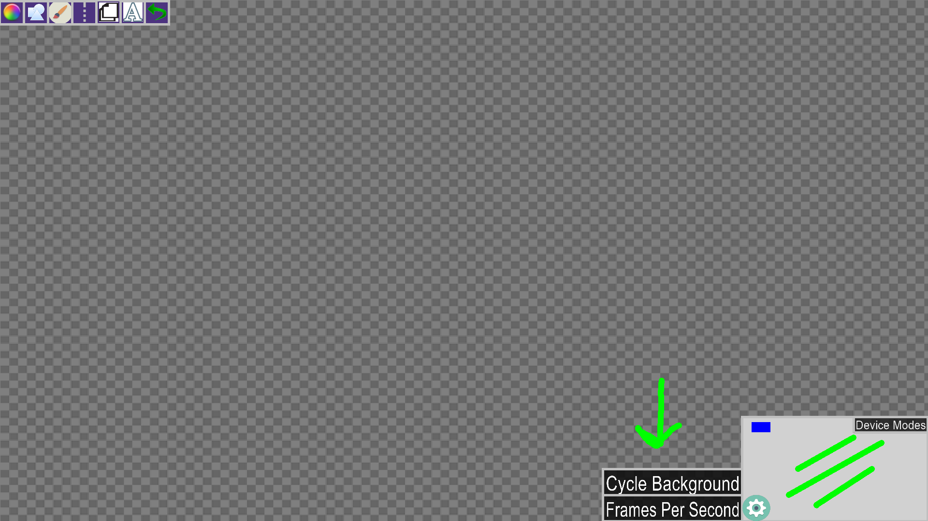

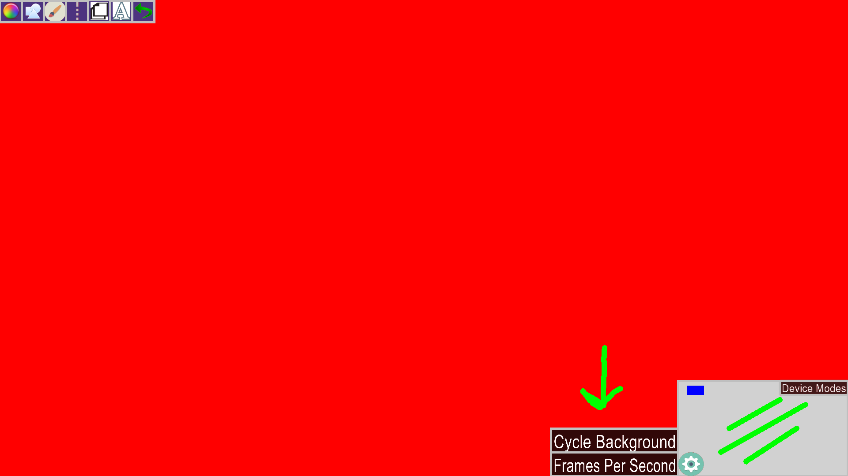

**Glossary**

Background – The color of the background of our image. A transparent background (checkerboard shape) will save the ‘background’ pixels as empty.